- INTRODUCTION

  - Project Overview

Explore with AI: Custom Itineraries for Your Next Journey is a generative AI–based web application designed to simplify and automate travel planning. The project allows users to generate personalized travel itineraries by providing basic inputs such as destination, number of days, and number of nights through an interactive web interface.
The system leverages a pre-trained generative AI model to create detailed and structured travel itineraries that include daily activities, nearby attractions, food recommendations, and useful travel tips. Instead of relying on manual research or static datasets, the application processes real-time user inputs and dynamically generates customized travel plans.
The application is developed using Python and Streamlit, providing a user-friendly interface for seamless interaction. By integrating generative AI with a lightweight web framework, the project demonstrates the practical application of AI in real-world travel planning scenarios. This solution is beneficial for individual travelers, travel agencies, and travel content creators by reducing planning effort, saving time, and improving the overall travel planning experience.

1.2 Objectives
- To develop an AI-based application for generating personalized travel itineraries.
- To use a pre-trained generative AI model for automated itinerary creation.
- To design a simple user interface using Streamlit for easy interaction.
- To validate user inputs for accurate and meaningful itinerary generation.
- To deploy the application as a working travel planning solution.

2. PROJECT INITIALIZATION AND PLANNING PHASE
2.1. Defining Problem Statement
Date | 28 January 2026
Team ID | LTVIP2026TMIDS65532
Project Name | Explore With Ai: Custom Itineraries For Your Next Journey
Maximum Marks | 3 Marks

Define Problem Statements (Customer Problem Statement Template):

Travel planning and content creation often take a lot of time and effort because they require continuous research and personalization. Many individual travellers find it difficult to create customized travel itineraries that match their interests and trip duration, which can be confusing and frustrating. In the same way, travel agencies struggle to quickly prepare personalized itineraries for multiple clients due to repetitive manual work. Travel websites and content creators also face challenges in regularly producing engaging and updated travel content. These difficulties create a need for an intelligent and automated solution. The Explore with AI system addresses these challenges by using generative AI to automatically generate personalized travel itineraries and relevant travel content with minimal manual effort.
Problem Statement (PS) | I am (Customer) | I’m trying to | But | Because | Which makes me feel
PS-1 | An individual traveller | plan a personalized travel itinerary | it requires extensive research and manual planning | travel information is scattered and not tailored to my preferences | confused and overwhelmed
PS-2 | A travel agency professional | generate customized itineraries for multiple clients | manual itinerary creation is time-consuming and repetitive | each client has different preferences and constraints | stressed and inefficient
PS-3 | A travel content creator or website owner | produce engaging and up-to-date travel content | creating fresh and relevant content regularly is difficult | content creation requires constant research and planning | pressured and creatively blocked

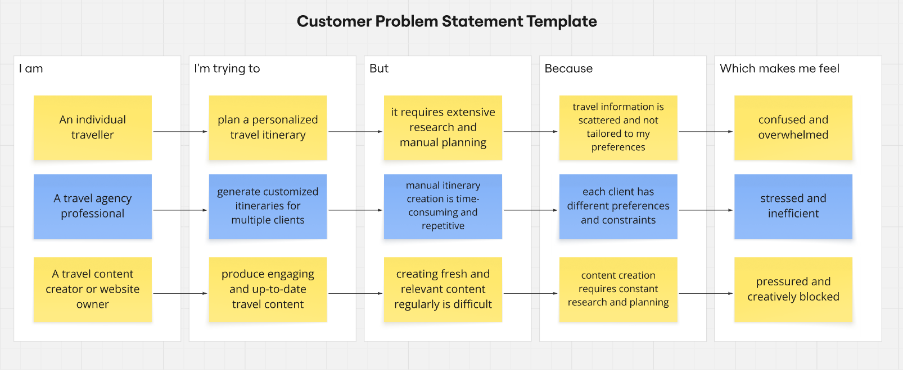
Reference: https://miro.com/templates/customer-problem-statement/

2.2. Project Proposal (Proposed Solution)
Date | 31 January 2026
Team ID | LTVIP2026TMIDS65532
Project Title | Explore With Ai: Custom Itineraries For Your Next Journey
Maximum Marks | 3 Marks

Project Proposal (Proposed Solution) template
Explore with AI: Custom Itineraries For Your Next Journey is a web-based application that helps users plan their trips easily. The system uses generative AI to create personalized travel itineraries based on user inputs such as destination, number of days, and nights. The application is built using Streamlit and provides a simple interface for users to generate travel plans quickly.
Project Overview
Objective | The main objective of this project is to develop an AI-based application that automatically generates customized travel itineraries, reducing the time and effort required for manual travel planning.
Scope | The project focuses on:  - Taking user inputs through a Streamlit web interface  - Using a generative AI model to create travel itineraries  - Displaying the generated itineraries to users  The project does not include booking services or payment features.
Problem Statement
Description | Creating personalized travel itineraries requires a lot of time and research. Travelers, travel agencies, and content creators often find it difficult to manually prepare customized and engaging travel plans.
Impact | An automated travel itinerary generator helps save time, improves efficiency, and makes travel planning easier for users by providing personalized results quickly.
Proposed Solution
Approach | The system collects travel details from users through a Streamlit interface. These details are sent to a generative AI model, which creates a detailed travel itinerary. The generated itinerary is then displayed to the user.
Key Features | - Personalized travel itinerary generation using AI  - Easy-to-use web interface  - Fast and automated content generation  - Input validation and error handling

Resource Requirements
Resource Type | Description | Specification/Allocation
Hardware
Computing Resources | Standard personal computer | Windows 11 Home Single Language
Memory | Minimum 4 GB | 16 GB
Storage | Minimum 20 GB free space | 256 GB SSD
Software
Frameworks | Python, Streamlit frameworks | Streamlit
Libraries | google-generativeai, streamlit | google-generativeai, streamlit
Development Environment | IDE, version control | Visual Studio Code, Git
Data
Data | Input Data: Destination, days, nights | User Input

2.3. Initial Project Planning
Date | 02 February 2026
Team ID | LTVIP2026TMIDS65532
Project Name | Explore With Ai: Custom Itineraries For Your Next Journey
Maximum Marks | 4 Marks

Product Backlog, Sprint Schedule, and Estimation (4 Marks)
Use the below template to create a product backlog and sprint schedule
Sprint | Functional Requirement (Epic) | User Story Number | User Story / Task | Story Points | Priority | Team Members | Sprint Start Date | Sprint End Date (Planned)
Sprint-1 | Project Setup | USN-1 | As a developer, I want to set up the project environment and install required libraries so that development can start smoothly. | 2 | High | M. Yuvaraj | 28 January 2026 | 31 January 2026
Sprint-1 | Model Initialization | USN-2 | As a developer, I want to generate and configure the Gemini API key to enable interaction with the generative AI model. | 2 | High | P. Anjali | 28 January 2026 | 31 January 2026
Sprint-2 | AI Integration | USN-3 | As a user, I want to generate a personalized travel itinerary by providing destination, days, and nights so that I can plan my trip easily. | 3 | High | K. Sree Vidya Lakshmi | 02 February 2026 | 09 February 2026
Sprint-2 | Prompt Handling | USN-4 | As a system, I want to send structured prompts to the Gemini model to generate meaningful and detailed itineraries. | 2 | Medium | R. Sindhu | 05 February 2026 | 09 February 2026
Sprint-3 | User Interface | USN-5 | As a user, I want a simple and interactive Streamlit interface to enter travel details and view generated itineraries. | 2 | High | P.Anjali, M.Yuvaraj | 10 February 2026 | 12 February 2026
Sprint-3 | Error Handling | USN-6 | As a user, I want the system to validate inputs and display error messages so that incorrect inputs are handled properly. | 1 | Medium | R.Sindhu, K.Sree Vidya Lakshmi | 12 February 2026 | 18 February 2026
Sprint-4 | Deployment | USN-7 | As a developer, I want to deploy the application using Streamlit so that users can access it through a web interface. | 2 | High | M.Yuvaraj, P.Anjali, R.Sindhu, K.Sree Vidya Lakshmi | 14 February 2026 | 18 February 2026

3. DATA COLLECTION AND PREPROCESSING PHASE
3.1. Data Collection plan and Raw Data Sources Identified
Date | 05 February 2026
Team ID | LTVIP2026TMIDS65532
Project Title | Explore With Ai: Custom Itineraries For Your Next Journey
Maximum Marks | 2 Marks

Data Collection Plan & Raw Data Sources Identification
This phase describes how data is collected and managed for the project. Since the application is based on a generative AI model, the data is collected dynamically from users rather than from static datasets.
Data Collection Plan
Section | Description
Project Overview | Explore with AI is a generative AI-based travel itinerary generation system. The project aims to generate personalized travel itineraries based on real-time user inputs such as destination, number of days, and number of nights using a pre-trained AI model.
Data Collection Plan | The data for this project is collected directly from users through a Streamlit-based web interface. The inputs are provided in real time and are processed immediately to generate customized travel itineraries. No external datasets are downloaded or stored as part of this project.
Raw Data Sources Identified | The raw data used in the system consists of user-provided input data entered through the application interface. This data is temporary and session-based, used only for generating the itinerary and not stored permanently.

Raw Data Sources
Source Name | Description | Location / URL | Format | Size | Access Permissions
User Input – Destination | Travel destination entered by the user | Streamlit Web Interface | Text | Small (per request) | Public (User Provided)
User Input – Trip Duration | Number of days and nights entered by the user | Streamlit Web Interface | Numeric | Small (per request) | Public (User Provided)
AI Model Response | Generated travel itinerary content | Generated at runtime | Text | Variable | Public (User Generated)

3.2. Data Quality Report
Date | 07 February 2026
Team ID | LTVIP2026TMIDS65532
Project Title | Explore With Ai: Custom Itineraries For Your Next Journey
Maximum Marks | 2 Marks

Data Quality Report
The data used in this project is collected dynamically from users through a web-based interface. Since no static dataset is used, data quality is ensured by validating user inputs before sending them to the generative AI model.

Data Source | Data Quality Issue | Severity | Resolution Plan
User Input (Destination) | Empty or unclear destination input | High | Input validation is applied to ensure the destination field is not empty before processing.
User Input (Days) | Invalid or zero number of days | High | Numeric validation ensures the number of days is greater than zero.
User Input (Nights) | Illogical or negative number of nights | Moderate | Input constraints ensure nights are zero or positive values.
Prompt Input | Incomplete or vague prompt generation | Moderate | Structured prompt formatting is used to ensure meaningful AI responses.
User Interaction | Repeated or incorrect submissions | Low | Error messages guide users to correct inputs before resubmission.

3.3. Data Preprocessing
Date | 09 February 2026
Team ID | LTVIP2026TMIDS65532
Project Title | Explore With Ai: Custom Itineraries For Your Next Journey
Maximum Marks | 6 Marks

Preprocessing
In the Explore with AI project, data preprocessing focuses on user-provided textual and numerical input rather than traditional datasets. Since the application uses a pre-trained generative AI model, no external dataset collection or complex preprocessing is required. Instead, preprocessing ensures that user inputs such as destination, number of days, and number of nights are clean, valid, and meaningful, enabling the generation of accurate and personalized travel itineraries.

Section | Description
Data Overview | The data used in this project consists of real-time user inputs such as travel destination, number of days, and number of nights. No external dataset is used.
Text Cleaning | User input text (destination) is cleaned by removing unnecessary spaces and checking for empty or invalid entries.
Input Validation | Ensures that the destination field is not empty, the number of days is greater than zero, and the number of nights is a valid non-negative value.
Token Handling | The validated input is passed to the Gemini generative AI model, which internally handles tokenization and text processing.
Prompt Formatting | The user inputs are formatted into a structured prompt before being sent to the AI model for travel itinerary generation.
Error Handling | The system handles invalid inputs and API-related issues gracefully. If incorrect or missing inputs are detected, appropriate error messages are displayed to guide the user. Any runtime or API errors are also caught and reported without crashing the application.
Data Preprocessing Templates
Loading Data | User inputs are collected directly through Streamlit input fields, including text and numeric inputs.
Input Validation | Validation logic ensures that all required inputs are provided and fall within acceptable ranges before further processing.
Prompt Creation | The validated user inputs are combined into a structured prompt that clearly specifies the destination and trip duration.
Model Invocation | The formatted prompt is sent to the pre-trained generative AI model to generate a personalized travel itinerary.
Output Handling | The generated itinerary is received as text output and displayed on the Streamlit interface for user review.

4. MODEL DEVELOPMENT PHASE
4.1. Model Selection Report
Date | 12 February 2026
Team ID | LTVIP2026TMIDS65532
Project Title | Explore With Ai: Custom Itineraries For Your Next Journey
Maximum Marks | 5 Marks

Model Selection Report
In this project, the focus is on selecting a suitable pre-trained generative AI model rather than training multiple machine learning models. The model selection was based on factors such as text generation quality, ease of integration, response speed, and suitability for natural language tasks like travel itinerary generation.
Model Selection Report:
Model | Description
Gemini Flash Lite (models/gemini-flash-lite-latest) | A lightweight and efficient generative AI model capable of producing coherent and context-aware text responses. It is well-suited for real-time applications such as travel itinerary generation and integrates easily using an API.
Other LLMs (Considered) | Other large language models were reviewed conceptually, but Gemini Flash was selected due to its fast response time, scalability, and strong support for natural language generation tasks.

Justification for Model Selection
The Gemini Flash model was chosen because it provides high-quality text generation with low latency, making it suitable for interactive web applications. Its ability to understand contextual prompts and generate structured travel itineraries aligns well with the project requirements. Additionally, the availability of a simple API interface allows seamless integration with the Streamlit application.

4.2. Initial Model Training Code, Model Validation and Evaluation Report
Date | 15 February 2026
Team ID | LTVIP2026TMIDS65532
Project Title | Explore With Ai: Custom Itineraries For Your Next Journey
Maximum Marks | 10 Marks

Initial Model Training Code, Model Validation and Evaluation Report
This project uses a pre-trained generative AI model and does not involve custom model training. Therefore, this phase focuses on model initialization, prompt-based interaction, and output evaluation instead of traditional training and validation.

Model Initialization and Integration (5 marks):
The generative AI model used in this project is a pre-trained Gemini Flash model provided through the Google Generative AI API. The model is initialized using a secure API key configuration and integrated into the application backend.
The model receives structured textual prompts containing user inputs such as destination, number of days, and number of nights. Based on this input, the model generates a detailed and personalized travel itinerary.
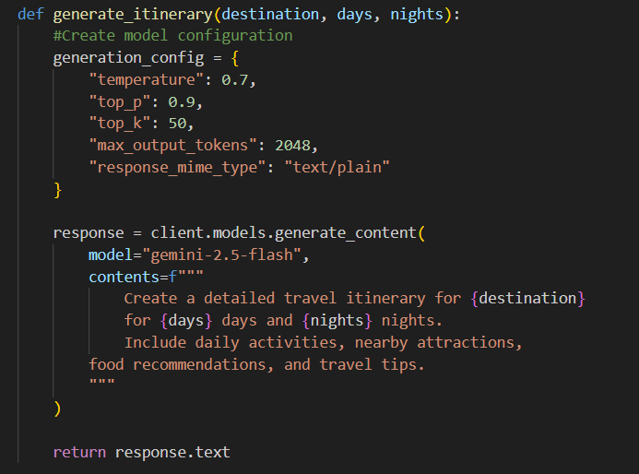

Model Validation and Evaluation Report (5 marks):
Since the model is pre-trained, validation is performed through functional testing and output quality assessment rather than numerical performance metrics.
Evaluation Criteria Used:
- Relevance of the generated itinerary to the selected destination
- Logical distribution of activities across days
- Completeness of itinerary (activities, attractions, food suggestions)
- Response consistency for different inputs
Multiple test inputs were provided to the system, and the generated outputs were reviewed to ensure accuracy, coherence, and usefulness.

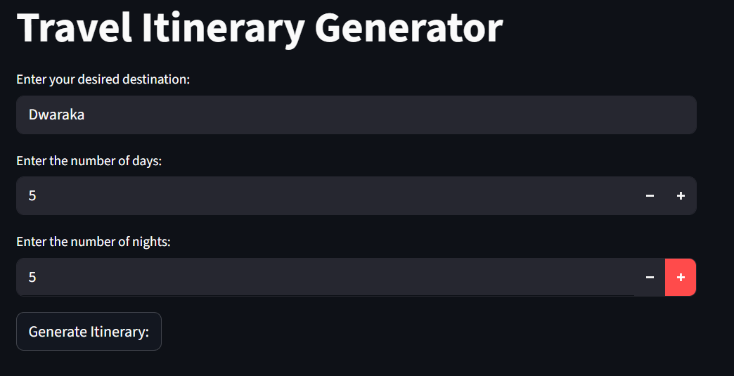
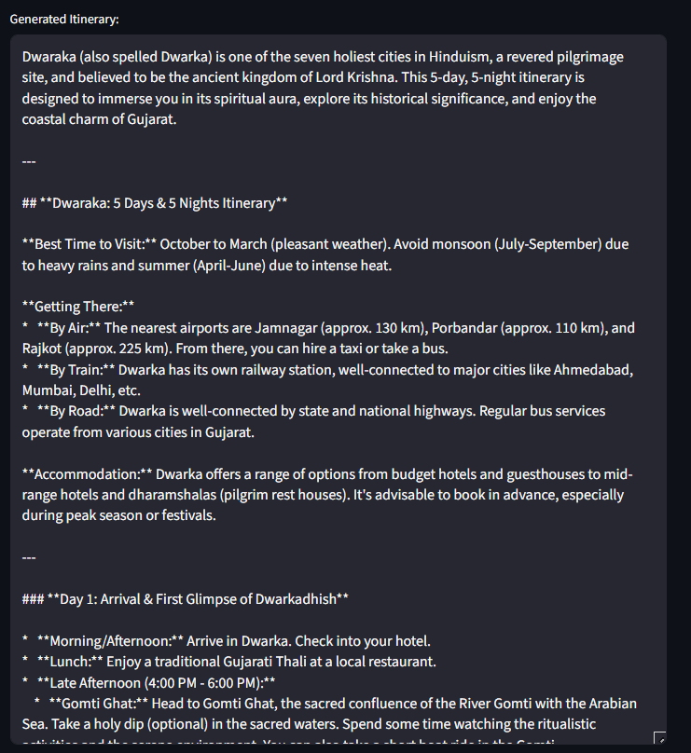

Model | Summary | Evaluation Method
Gemini Flash Lite | Large Language Model used via API | Output quality validation through multiple test cases

5. MODEL OPTIMIZATION AND TUNING PHASE
5.1. Tuning Documentation
Date | 18 February 2026
Team ID | LTVIP2026TMIDS65532
Project Title | Explore With Ai: Custom Itineraries For Your Next Journey
Maximum Marks | 10 Marks

Model Optimization and Tuning Phase
Since this project uses a pre-trained generative AI model, traditional model retraining and fine-tuning are not performed. Instead, optimization is achieved by tuning generation parameters and improving prompt structure to enhance the quality, relevance, and consistency of the generated travel itineraries.
Model | Tuned Parameters | Description
Gemini Flash (Pre-trained LLM) | Temperature | Controls creativity of responses. A moderate value was chosen to balance creativity and relevance.
 | Top-p | Ensures coherent and focused output by limiting token probability range.
 | Top-k | Restricts token selection to the most relevant options for better response quality.
 | Max Output Tokens | Limits response length to generate detailed but concise itineraries.

Hyperparameter Tuning Documentation (8 Marks):

Optimization Approach

Initial responses were tested with default settings

Generation parameters were adjusted iteratively

Outputs were evaluated based on clarity, structure, and relevance

The configuration producing the most consistent itineraries was selected

5.2 Final Model Selection Justification (2 Marks):
Final Model | Reasoning
Gemini Flash Lite (models/gemini-flash-lite-latest) | The final configuration provided the best balance between detailed itinerary generation, response consistency, and fast execution. The tuned parameters improved output quality without increasing computational complexity, making it suitable for real-time user interaction.

6. RESULTS
6.1. Output Screenshots
The complete execution of Explore with AI: Custom Itineraries for Your Next Journey application is represented step by step in the following screenshots.
Step 1: To run the Streamlit Application we have to use the command streamlit run travel.py in the terminal in path where the travel.py file is located.
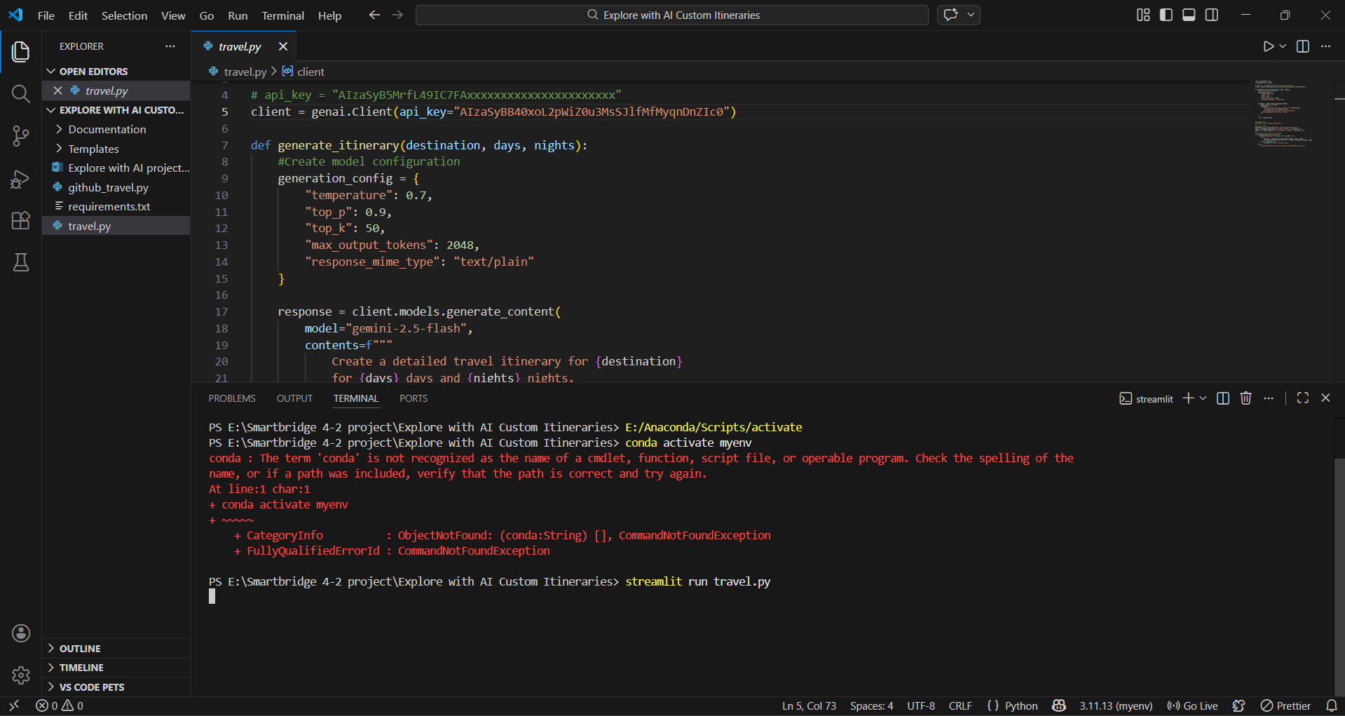

Step 2: After running the command in terminal, the code will get executed and the webpage will open directly. Another way to open webpage is that a localhost link will get generated in the terminal, we can access the webpage using that link.
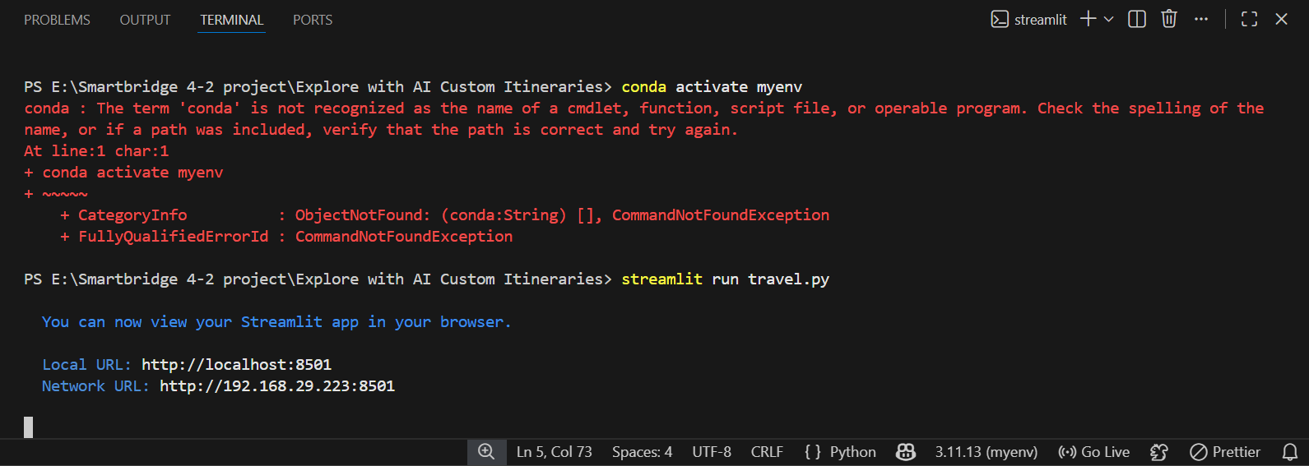
Step 3: The Streamlit webpage opens as shown in the figure given below. This is an automated webpage. No secondary HTML codes required to build this webpage. Python code itself consists the webpage building code.
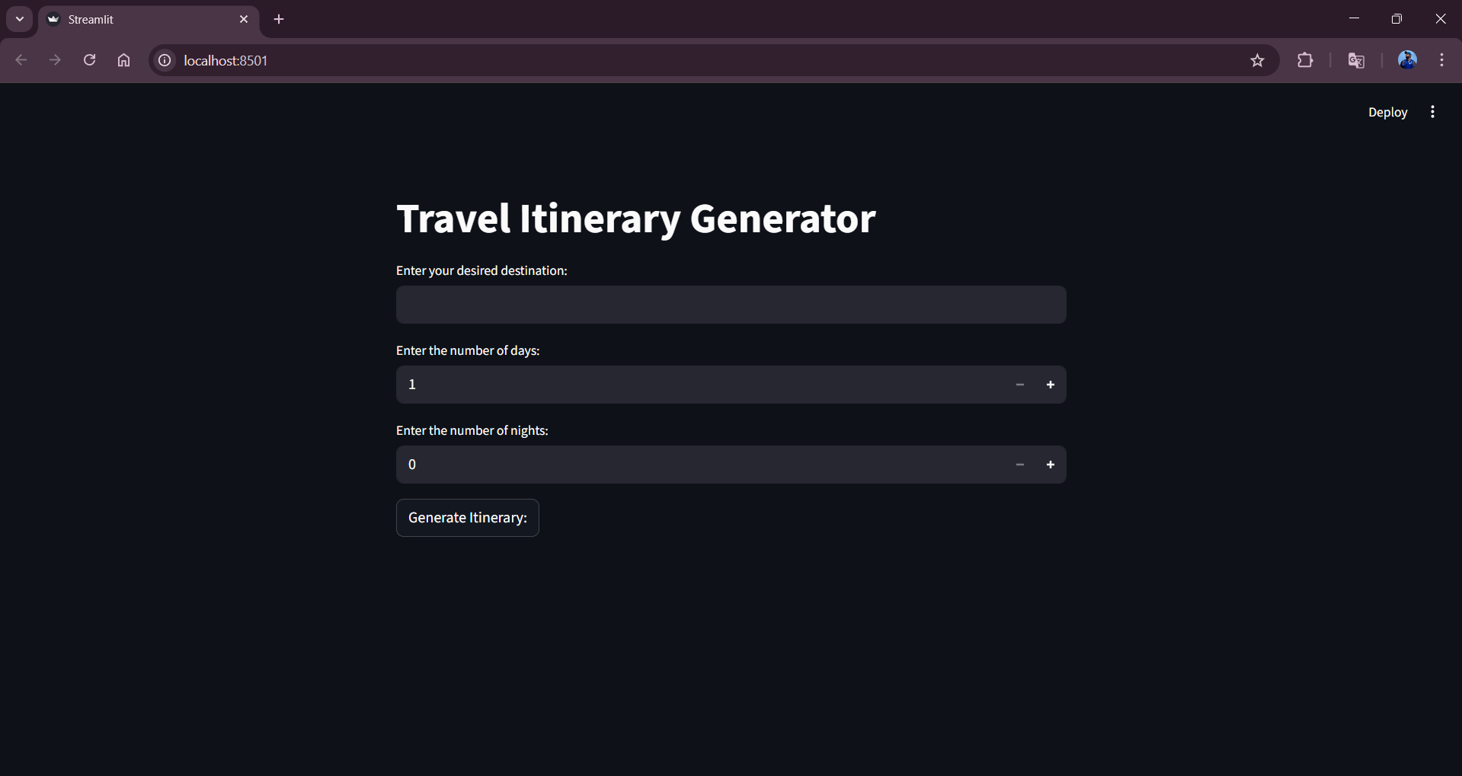
Step 3: The user has to give inputs in the website such as desired Destination Name, Number of Days and Number of Nights. The Number of Days and Nights mean in how many days and nights, the user wants their travel planning to be made. After entering the required details, the user should click on Generate Itinerary button to generate the travel plan. Here I chose the destination as Tirumala, days as 4 and nights as 5.
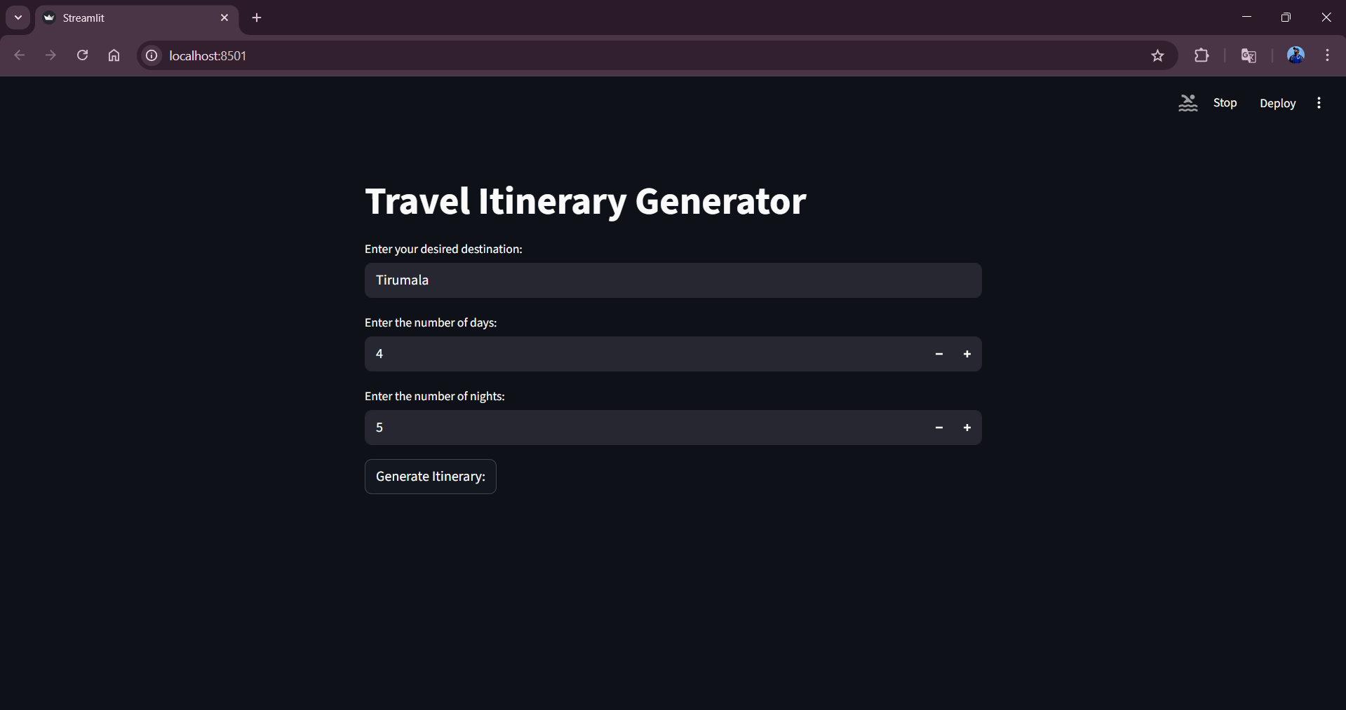
Step 4: After clicking the Generate Itinerary button, in fraction of seconds the itinerary will be generated based on the user input as shown in the following images.
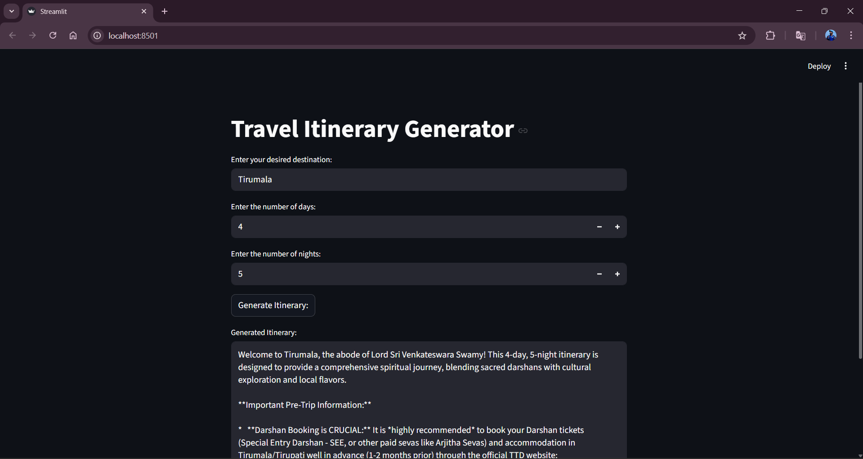
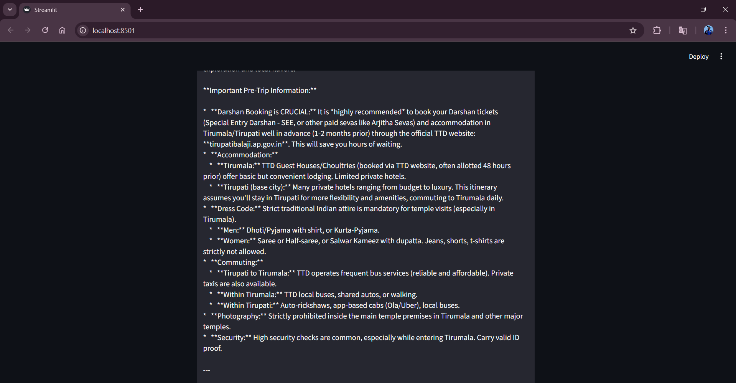
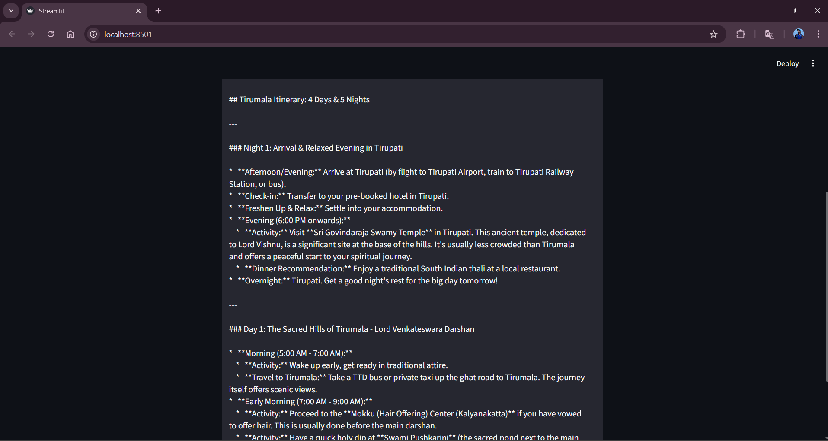
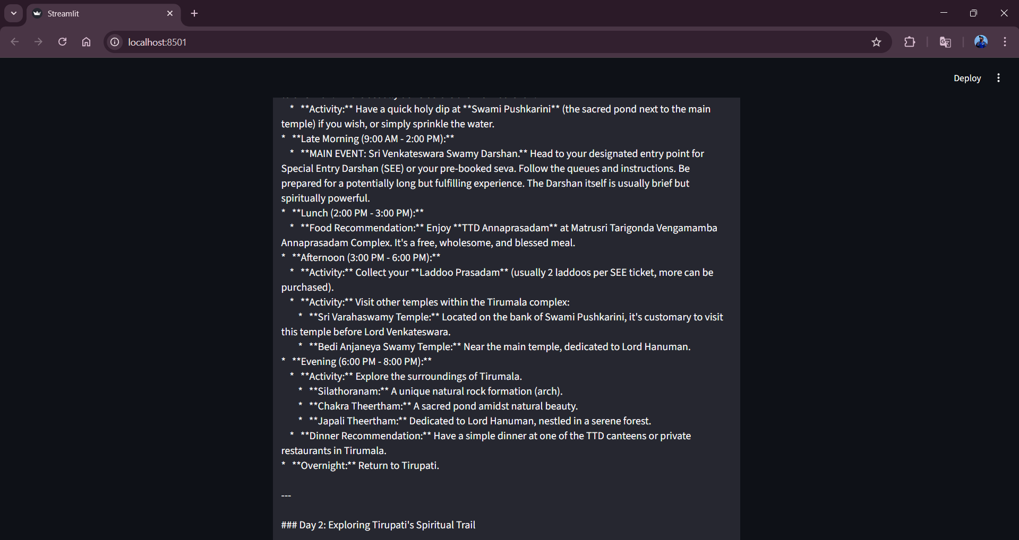
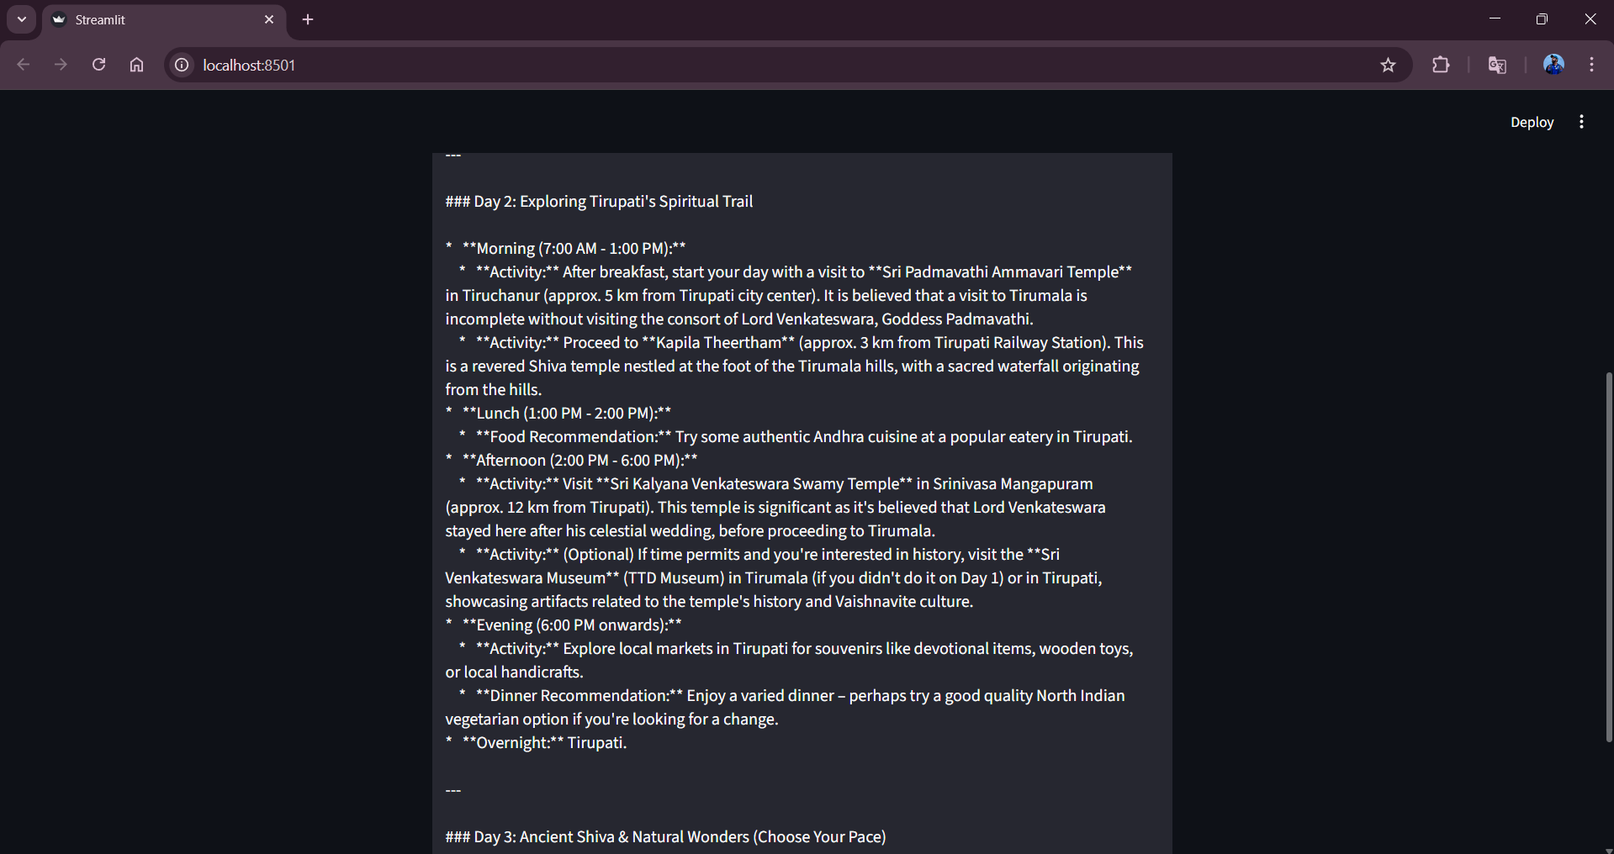
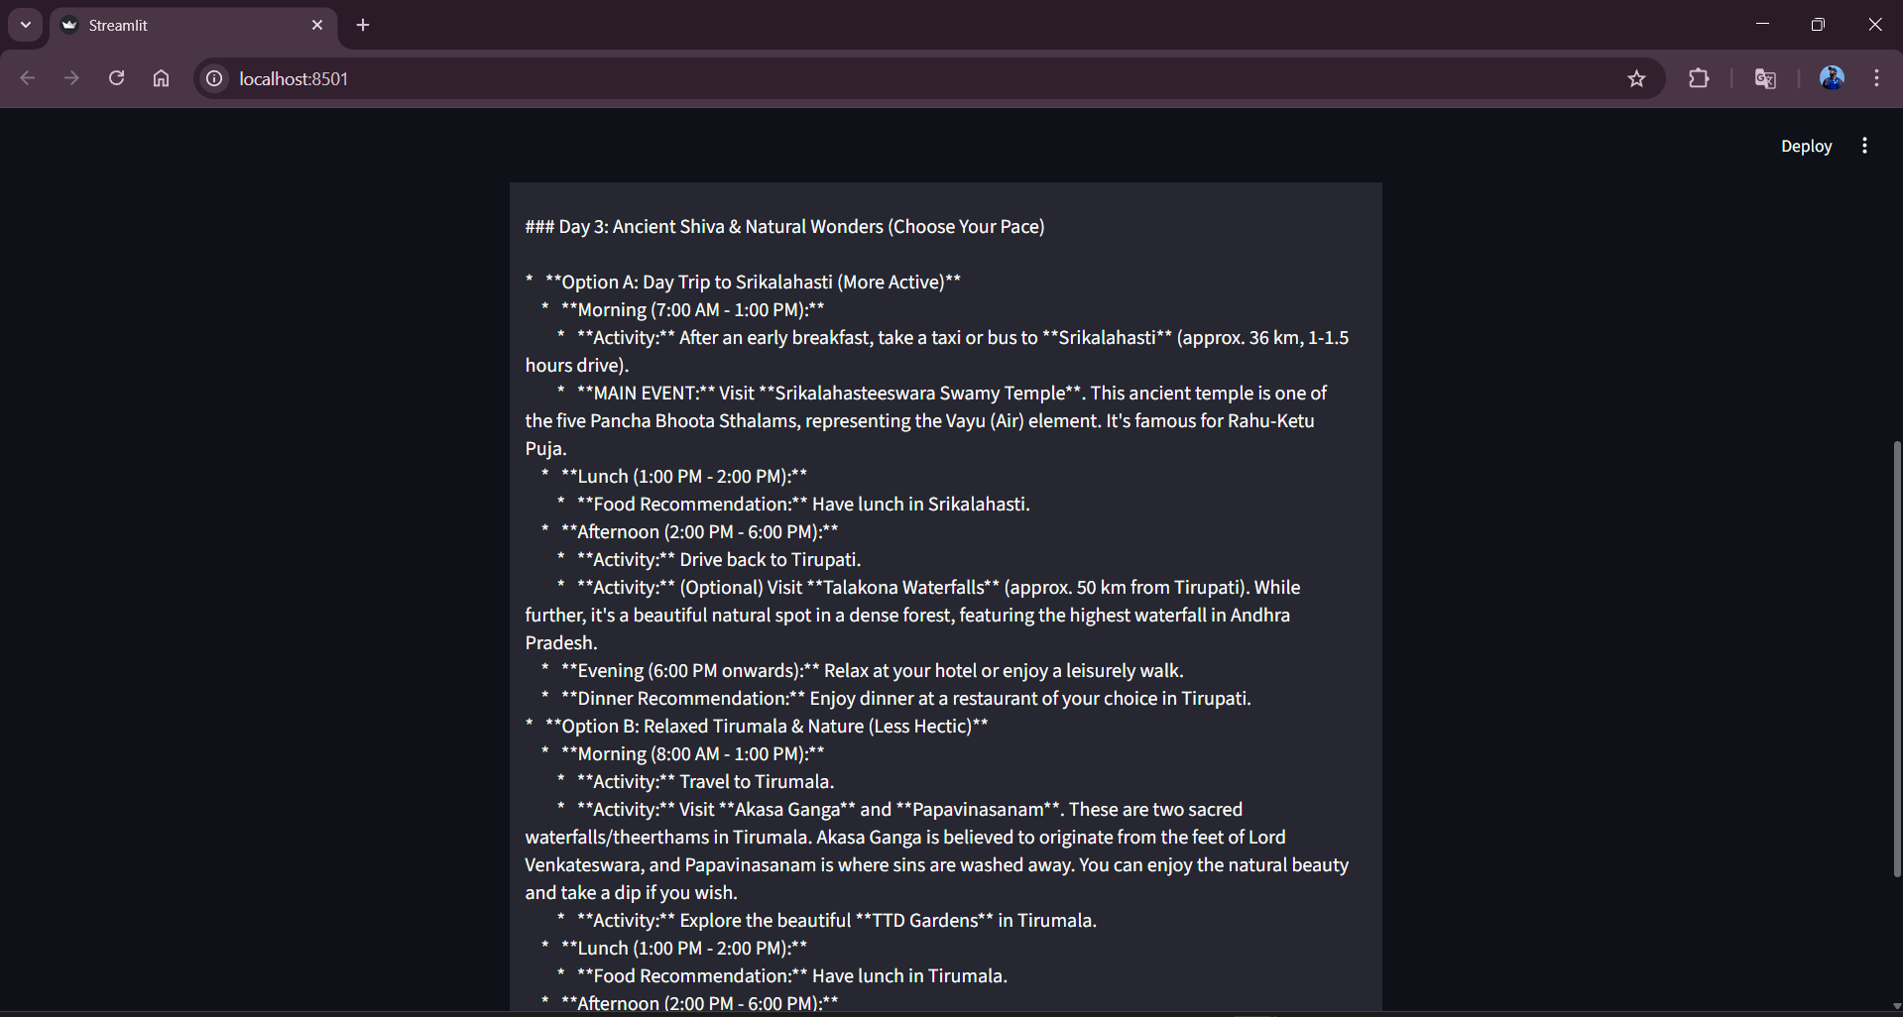
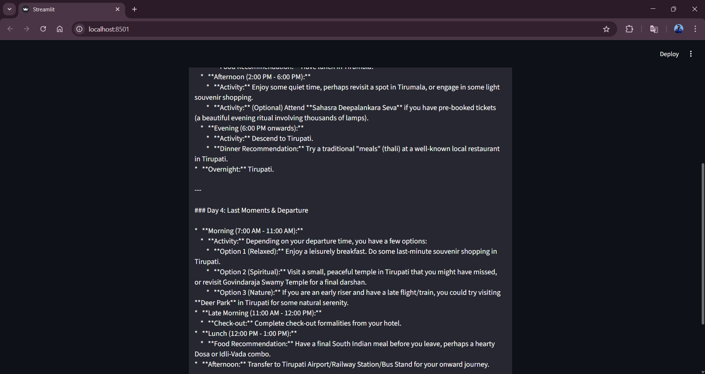
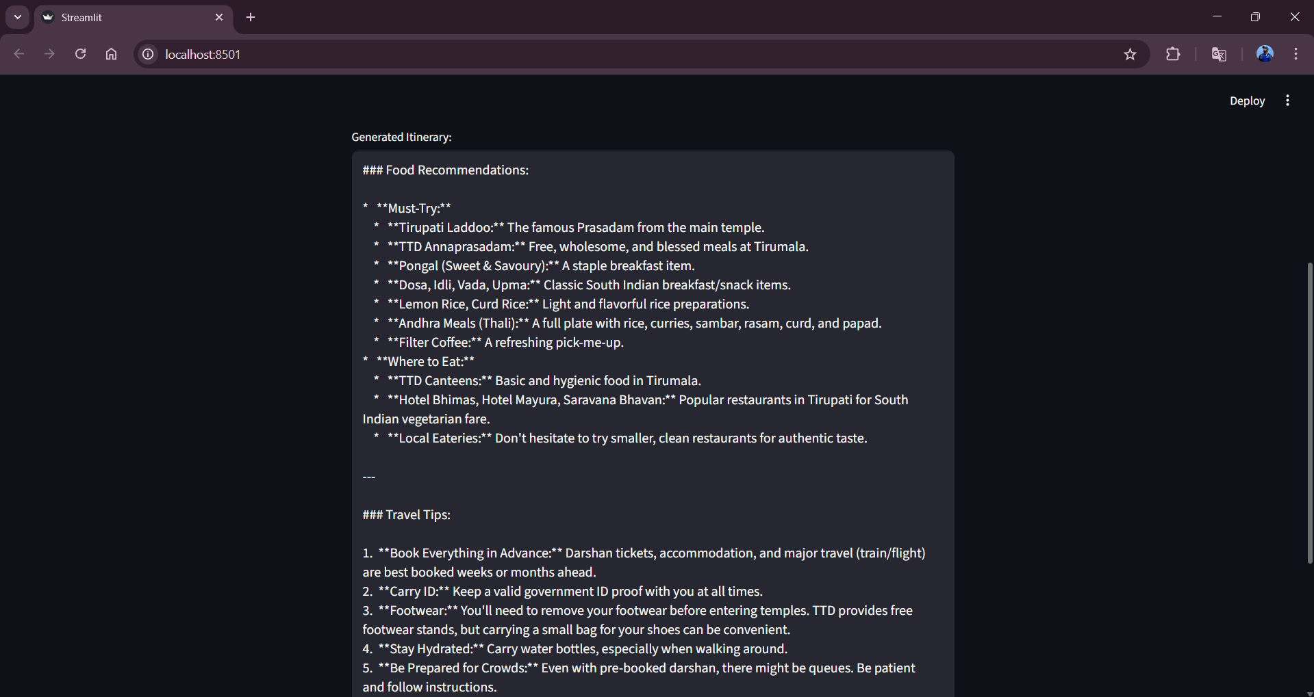
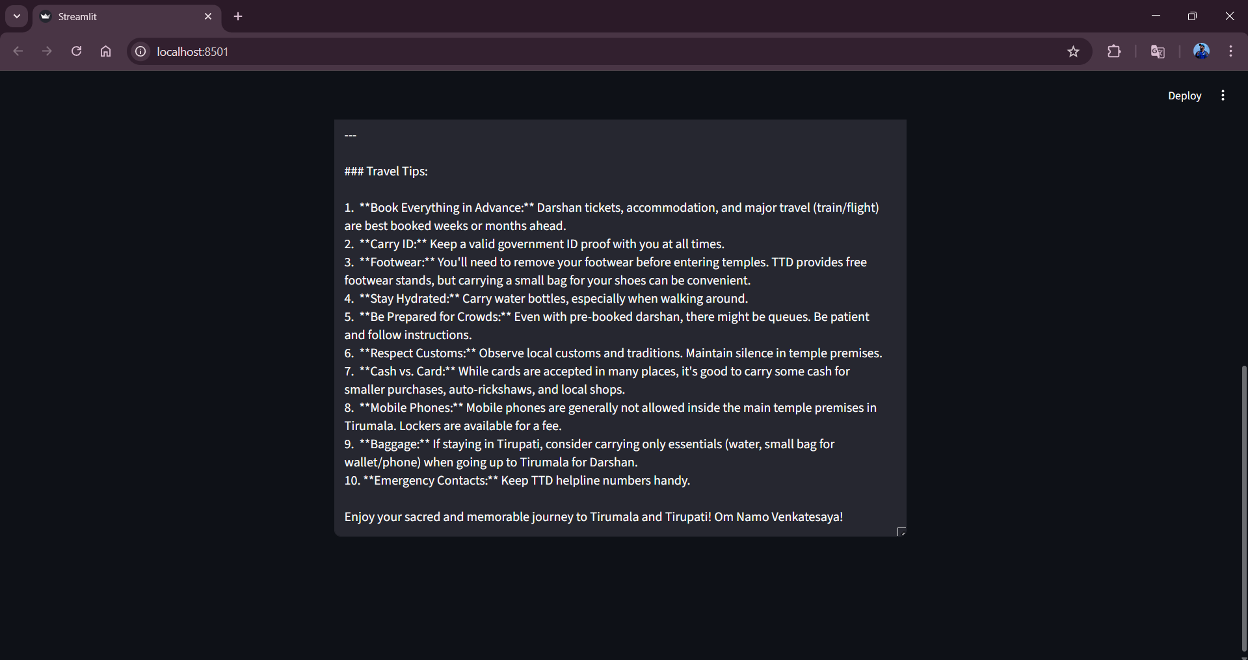

7. ADVANTAGES AND DISADVANTAGES
Advantages
- Automates travel itinerary creation, saving time and effort for users.
- Generates personalized travel plans based on user preferences and trip duration.
- Easy-to-use interface built with Streamlit, suitable for non-technical users.
- Uses a pre-trained generative AI model, eliminating the need for model training.
- Can be extended to support travel agencies and content creators.

Disadvantages
- Depends on internet connectivity and availability of the AI API.
- Generated itineraries may not always reflect real-time travel conditions.
- Limited customization options in the current version of the application.
- Does not include booking, cost estimation, or real-time availability features.
- API usage may incur cost limitations based on usage quotas.

8. CONCLUSION
The Explore with AI project demonstrates how generative AI can be used to simplify travel planning by automatically generating personalized travel itineraries. The application integrates a pre-trained AI model with a Streamlit interface to provide quick and user-friendly itinerary generation. This project highlights the practical use of AI in real-world applications and serves as a foundation for future enhancements in intelligent travel planning. The developed application serves as a functional prototype that can be further expanded with additional features, making it a valuable tool for travelers, travel agencies, and content creators.

9. FUTURE SCOPE
The application can be enhanced by allowing users to specify additional preferences such as budget, travel style, and accommodation type. Real-time data such as weather updates, local events, and travel advisories can be integrated for more accurate itineraries. Booking features for hotels, transportation, and tourist attractions can be added to make the system more comprehensive. Multi-language support can be introduced to serve users from different regions. The system can be deployed on cloud platforms and scaled to support a larger number of users.

10. APPENDIX
10.1. Source Code
The source code for the Explore with AI: Custom Itineraries for Your Next Journey project includes the implementation of the Streamlit user interface, integration of the Gemini Flash model using the Google Generative AI API, travel plan/ itinerary generation logic, and plan upgrading based on the number of days and nights given by the user feature. The code is written in Python and follows a modular and readable structure.
10.2. Github & Project Demo Link
- Demo Video Link:
https://drive.google.com/file/d/1nyrbCrYjuLKzrgCEq3VMfWrk_3KKTpHM/view?usp=drive_link

- Github Repository:
https://github.com/Sree-Vidya-Lakshmi-Kuravi/Explore-with-AI-Custom-Itineraries-For-Your-Next-Journey

